Recipe 4-3: Saving RMAN Output to a Text File

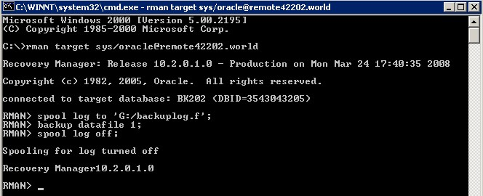

Here is the output of my log file:

Spooling started in log file: G:/backuplog.f

Recovery Manager10.2.0.1.0

RMAN>
Starting backup at 24-MAR-08
using target database control file instead of recovery catalog
allocated channel: ORA_DISK_1
channel ORA_DISK_1: sid=98 devtype=DISK
channel ORA_DISK_1: starting full datafile backupset
channel ORA_DISK_1: specifying datafile(s) in backupset
input datafile fno=00001 name=C:\MSCD642\DBMS\APP\ADMIN\BK202\ORADATA\DISK1\SYSTEM01.DBF
channel ORA_DISK_1: starting piece 1 at 24-MAR-08
channel ORA_DISK_1: finished piece 1 at 24-MAR-08
piece handle=C:\ORACLE\PRODUCT\10.2.0\DB_1\DATABASE\07JC34MO_1_1 tag=TAG20080324T164408 comment=NONE
channel ORA_DISK_1: backup set complete, elapsed time: 00:00:35
channel ORA_DISK_1: starting full datafile backupset
channel ORA_DISK_1: specifying datafile(s) in backupset
including current control file in backupset
including current SPFILE in backupset
channel ORA_DISK_1: starting piece 1 at 24-MAR-08
channel ORA_DISK_1: finished piece 1 at 24-MAR-08
piece handle=C:\ORACLE\PRODUCT\10.2.0\DB_1\DATABASE\08JC34NR_1_1 tag=TAG20080324T164408 comment=NONE
channel ORA_DISK_1: backup set complete, elapsed time: 00:00:03
Finished backup at 24-MAR-08

RMAN>

RECIPE 4-4: Logging Command-Line RMAN Output

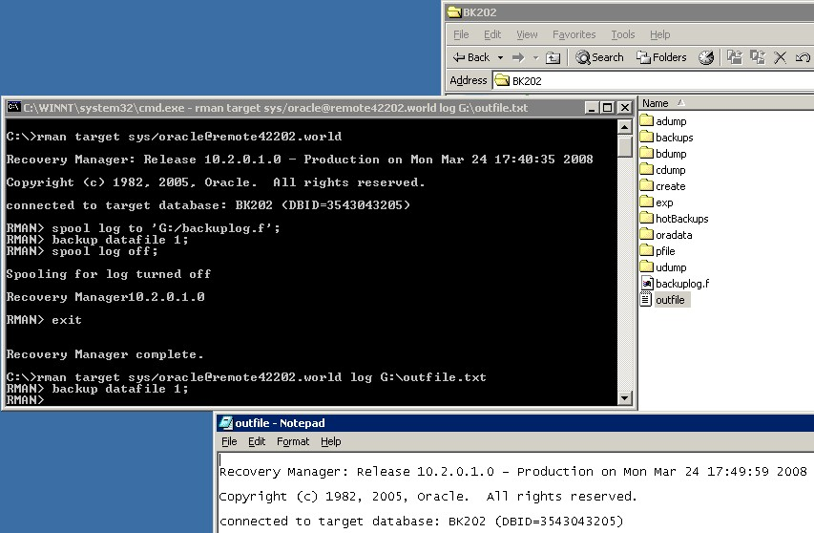

(the next screen-shot is me simply playing around with the RMAN views)

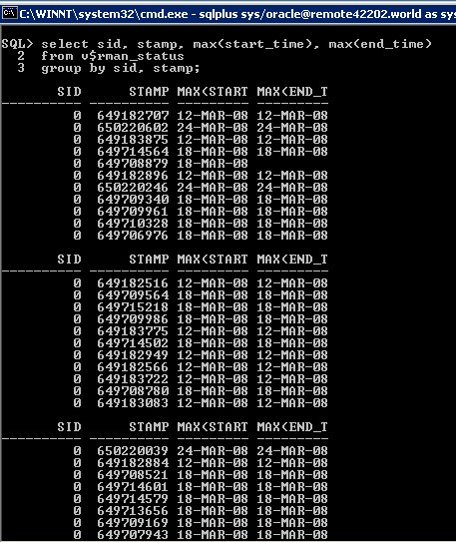
Recipe 5-1: Showing RMAN Configuration Settings

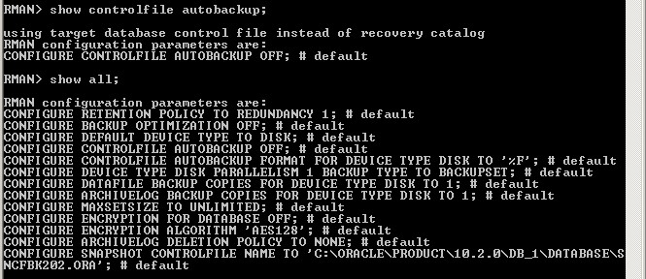

I took a screen shot of my selection of v$rman_configuration, but it turned up with no results. I assume this is because all settings are set to default.

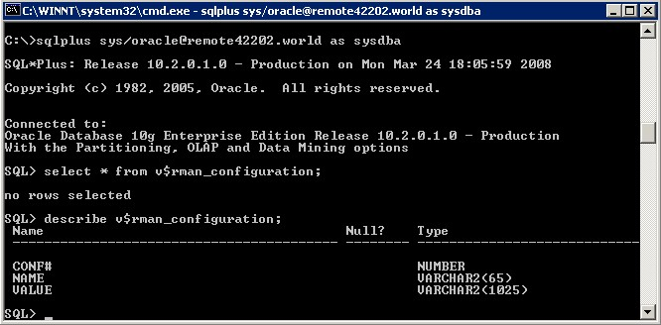
Recipe 5-2: Configuring RMAN

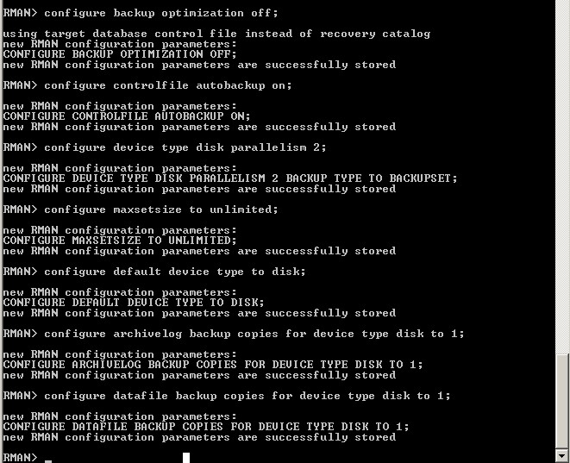
Recipe 5-3: Restoring Default Parameter Settings

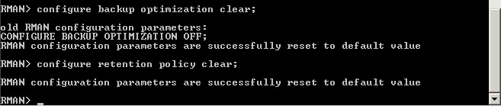
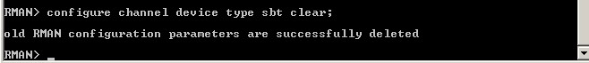

Recipe 5-4: Enabling and Disabling Automatic Control File Backups

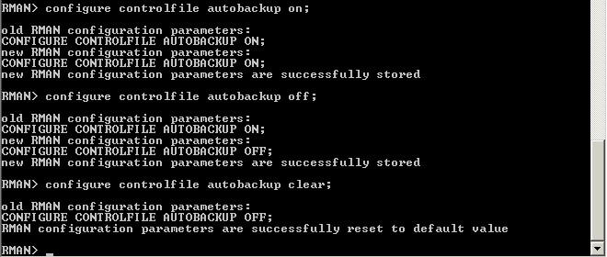
Recipe 5-8: Configuring the Default Device Type
(I didn’t run the sbt backups as I assume we have no tape drive to backup to)
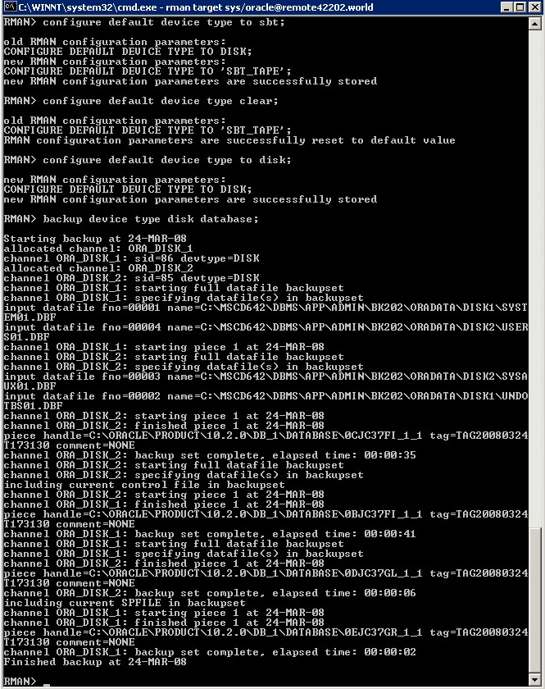
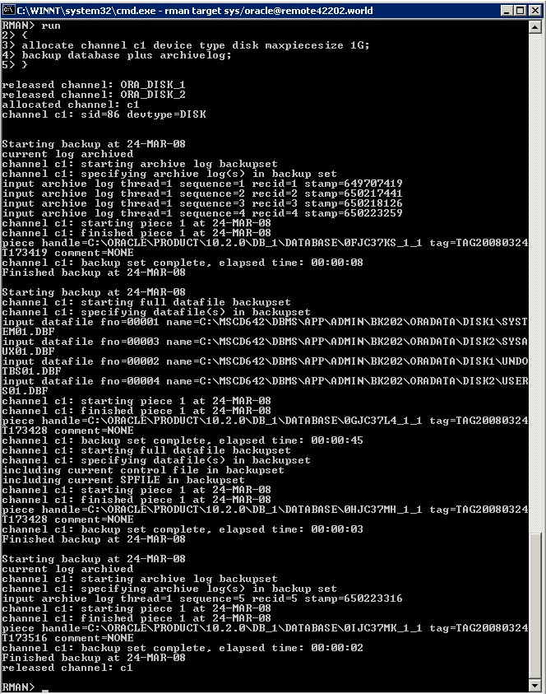
Recipe 5-9: Configuring the Default Backup Type

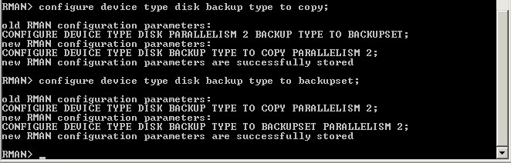

Recipe 5-19: Creating a Backup Retention Policy

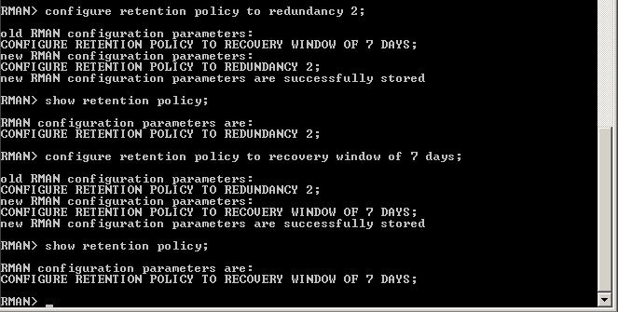
Recipe 7-3: Backing up the Server Parameter File

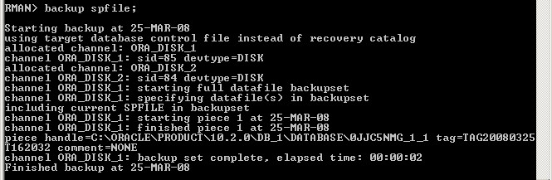

Recipe 7-5: Backing Up Tablespaces

(I’m backing up only the users tablespaces as “tools” isn’t in this Citrix db)
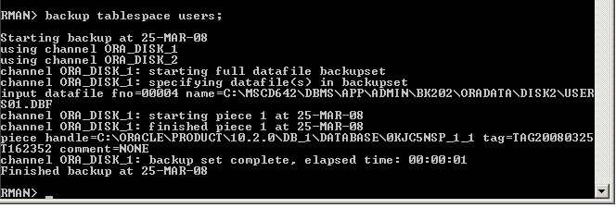
Backup while specifying the format parameter
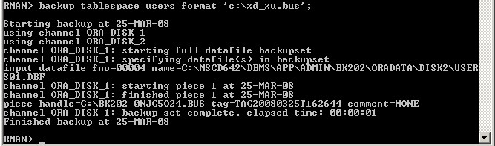
Make a tablespace image copy
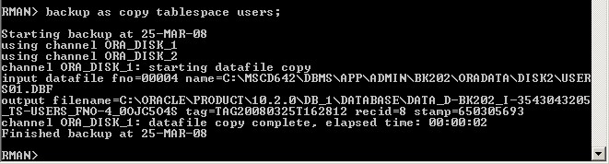
Make in incremental tablespace backup
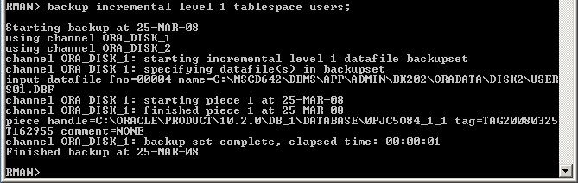

Recipe 7-7: Backing Up Archived Redo Logs

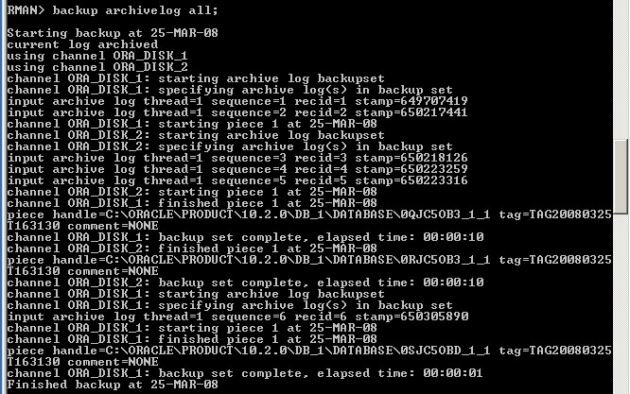

(not running the second part – backup device type sbt … -- as we have no tape drive to back up to)

Use a specified time of archivelogs to backup
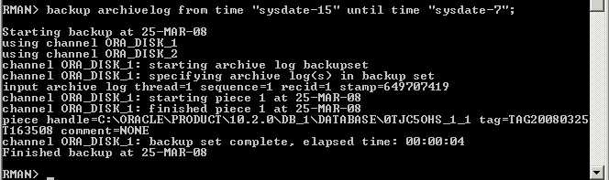

Backup a specific archived log and delete it after backup
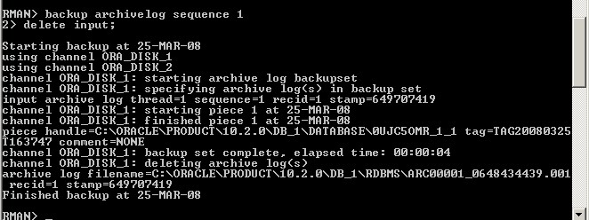

Recipe 7-8: Backing Up Everything

Backup up the database as well as the archived redo logs
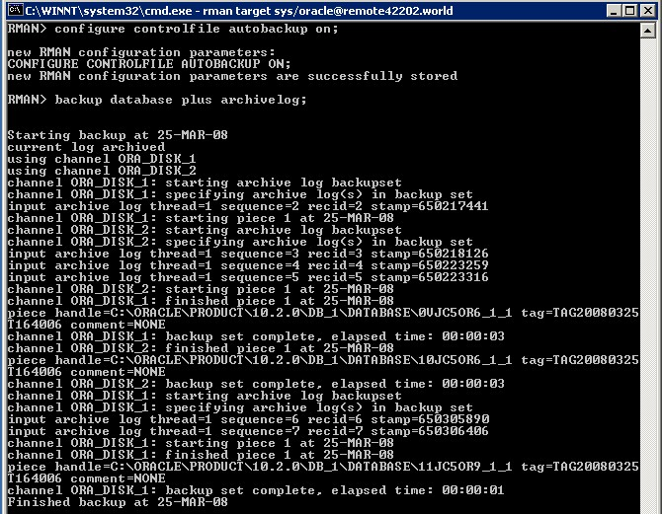
(continued on next page)
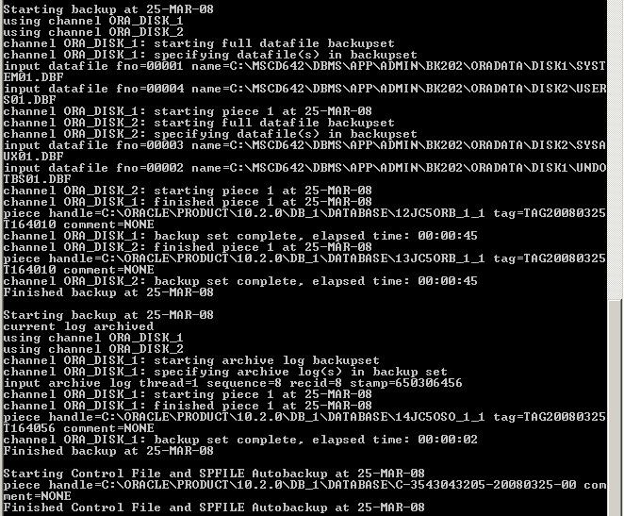
Display all the backups stored:
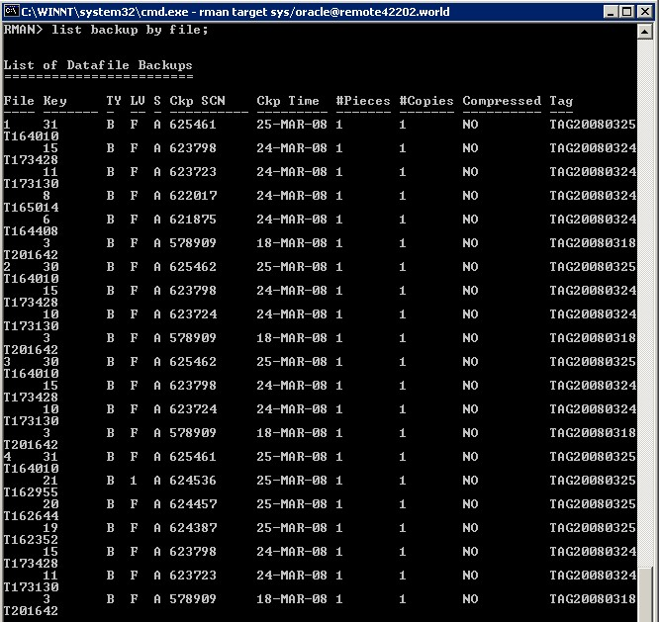

(continued on next page)
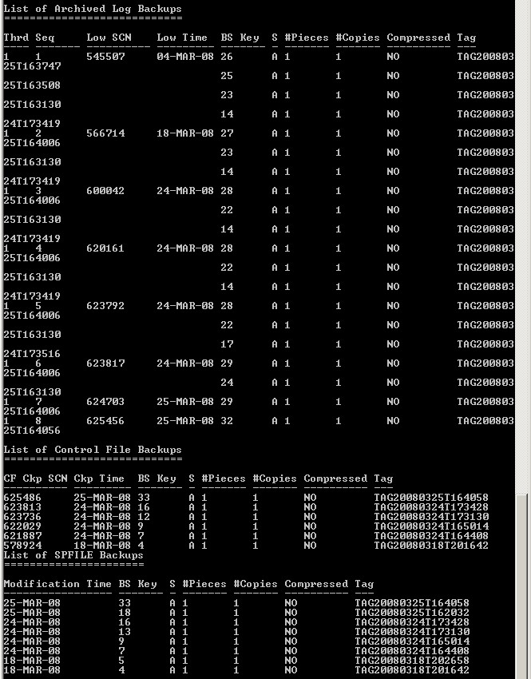
Backup database when controlfile autobackup is off
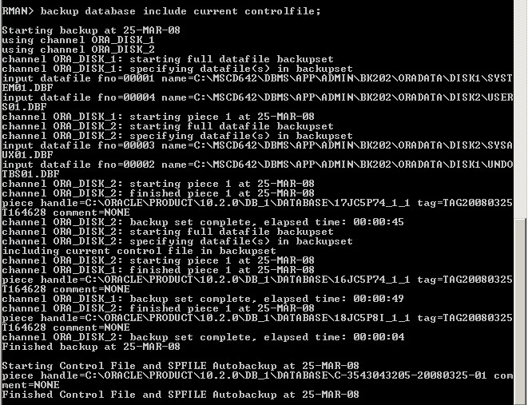
Recipe 8-2: Finding datafiles and archivelogs that need a backup
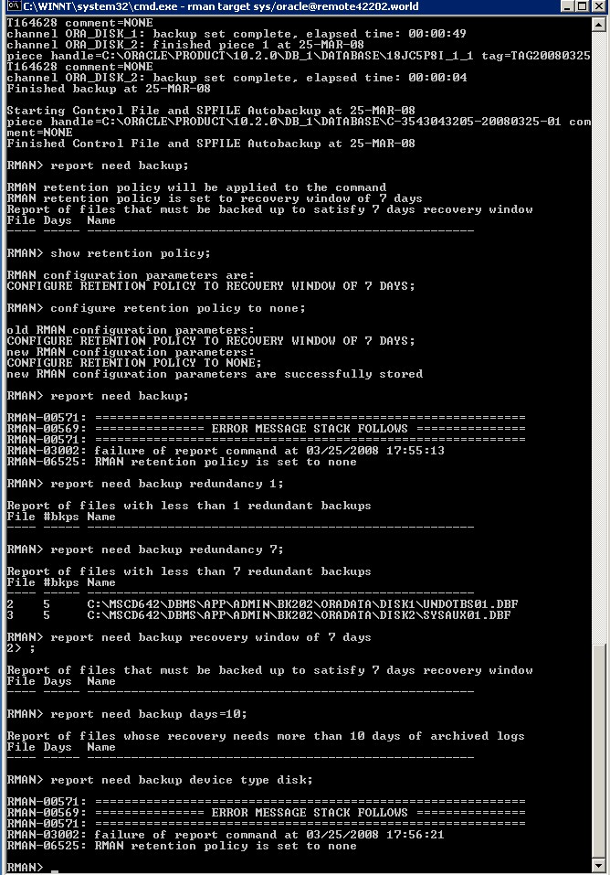
Recipe 8-3: Finding Datafiles Affected by Unrecoverable Operations
I had to set the retention policy back to something other than none in order for this to work, FYI, that isn’t mentioned in the book.
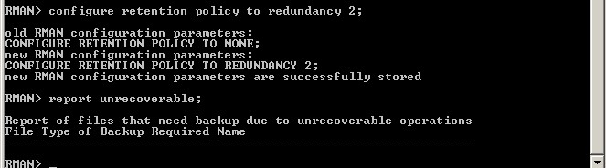

Recipe 8-4: Identifying Obsolete Backups

Crosscheck backup
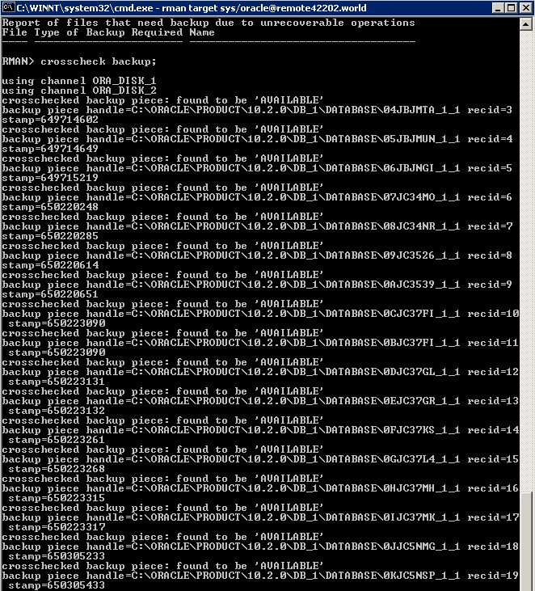

(continued …)
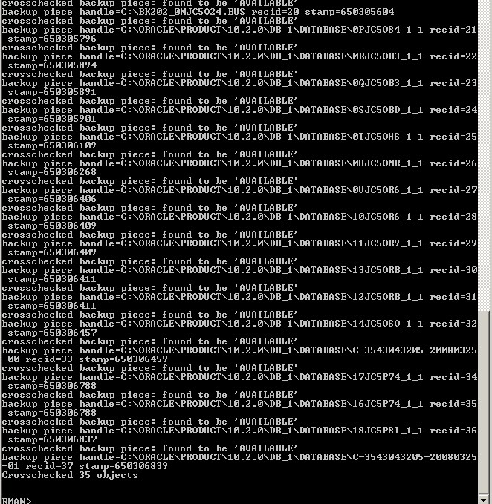

Report obsolete
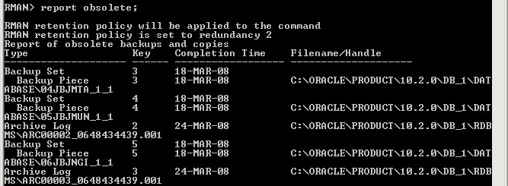
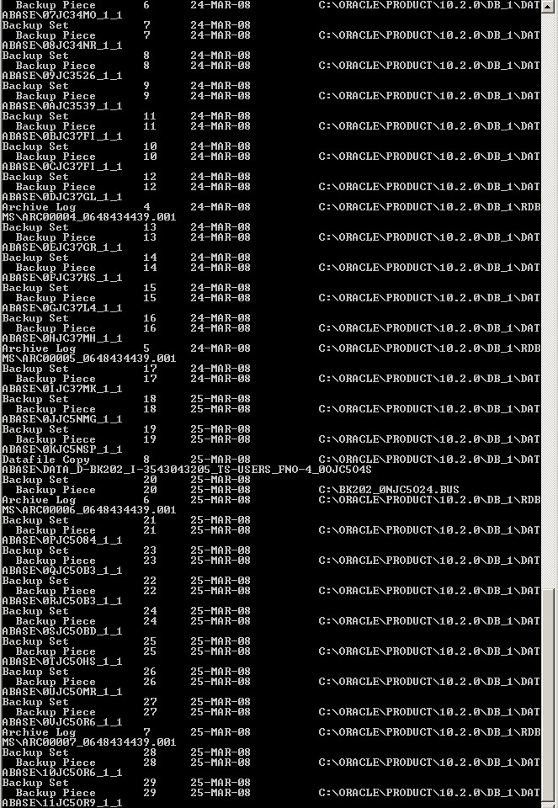

Specify redundancy and recovery window options
(note: I didn’t do the “redundancy 2” example as that is what my retention policy is currently set to)

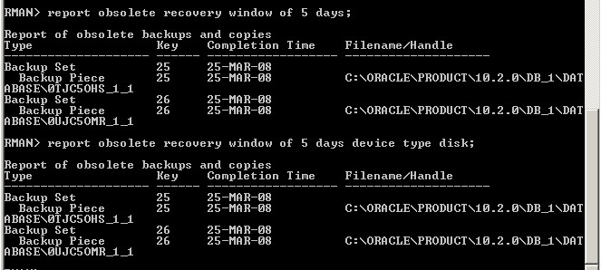

Recipe 8-6: Listing RMAN Backups

Note: I spooled this one as the results would take a ton of screen shots, I have sent you my spooled file the below commands generated.

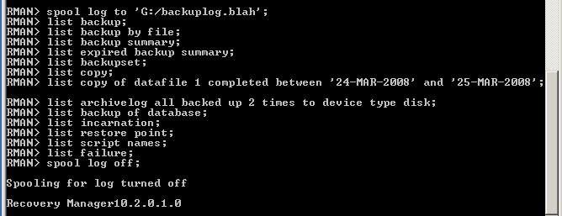
Recipe 8-18: Testing the Integrity of an RMAN backup
Check for physical corruption of any datafiles or archived redo logs
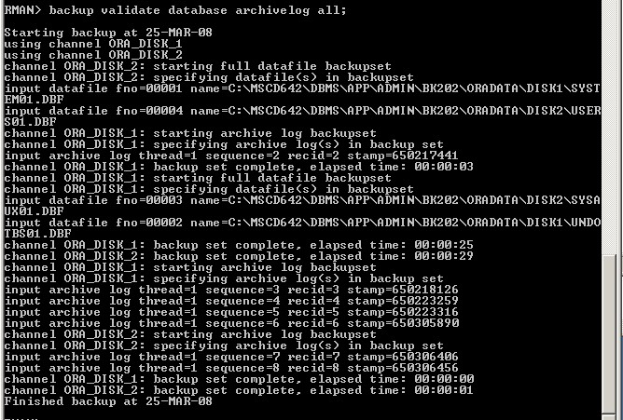
Check for logical corruption as well
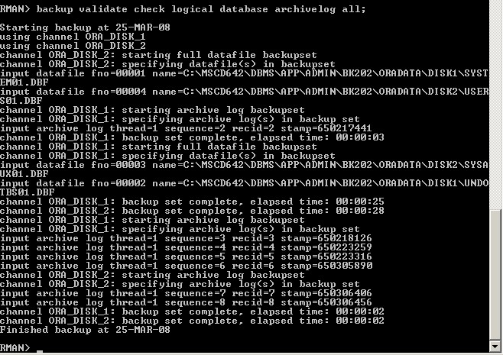
Recipe 8-19: Validating Datafiles, Backup Sets, and Data Blocks
Validate a single file
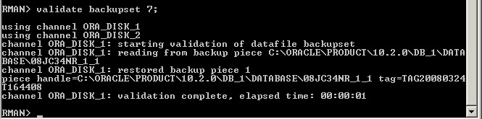
Validate all datafiles
(this feature is available in 11g)

